EXP.10:-Blinking of LED using CupCarbon
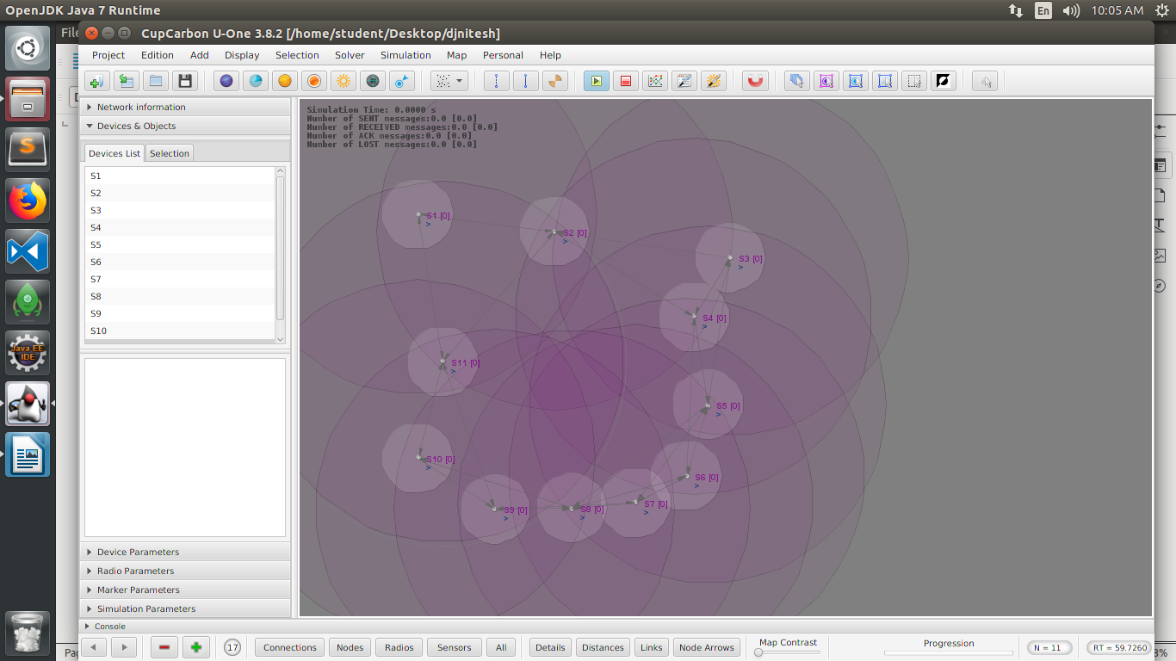

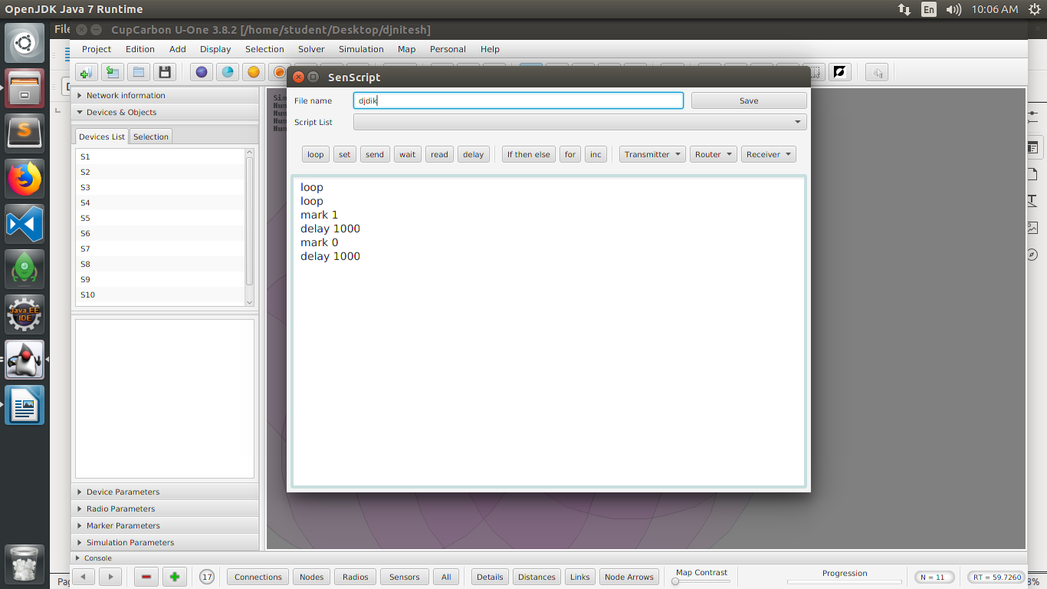

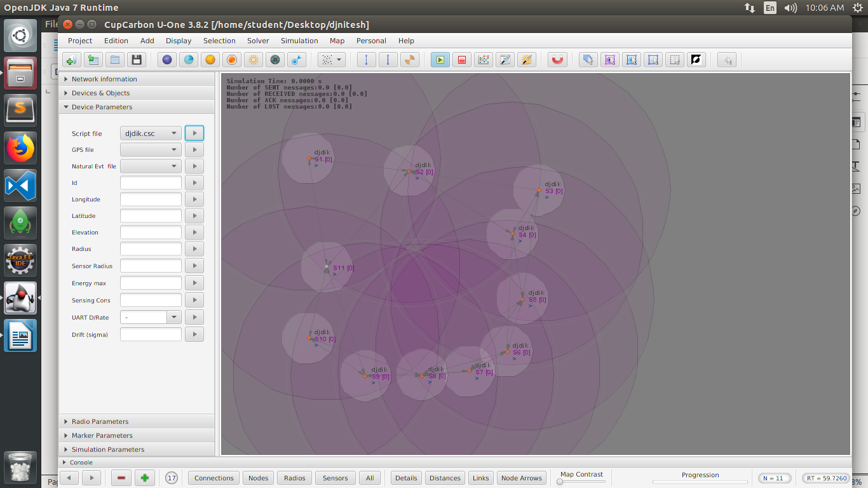
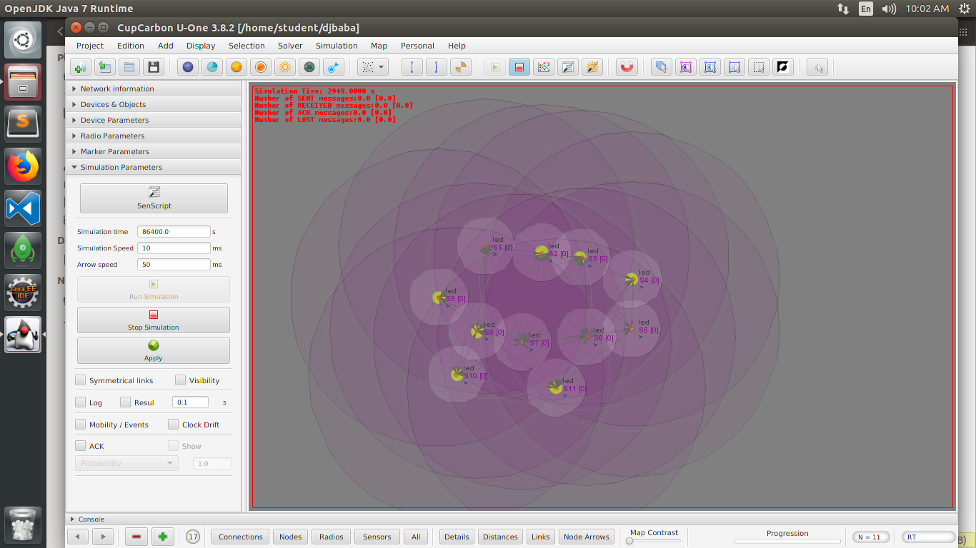
Code-
loop
mark 1
delay 1000
mark 0
delay 1000

Conclusion-Thus we successfully blink led using cupcarbon.

